**Sprint 1 Plan**

Lost & Found

Team Rocket

Sprint Completion Date: 07/09/2018

**Goals**

*Short, 1-2 sentence description of the high-level goal(s) for the sprint.*

The goal of this sprint is to get a skeleton “crud” application running. The user will be able to navigate to the web page and choose between three different functions: “Lost,” “Found,” and “All.” Both the “Lost” and “Found” buttons will allow the user to submit a form that will add a new entry to the database. The “All” button will display all of the current entries in the database.

**Task Listing**

*This section lists the user stories, in priority order from most important (top) to least important (bottom). Within each user story, there needs to be a list of tasks required to implement the user story, along with the time estimate for each tasks (preferably less than or equal to 6 ideal hours).*

* **User Story 1**: As a user who has lost an item, I want to access a separate web application specifically for lost and found items at UCSC, so that I only have to look/post in one place. [8 hours]
  + **Task 1:** Learn Adobe XD and Vuetify [4 hours ]
  + **Task 2**: Design the homepage of the web app in Adobe XD [1 hour]
  + Convert the design to actual code using Vuetify]
    - **Task 3:** Write code for placeholder buttons (“Lost”, “Found”, “Display”) [ 0 hours]
    - **Task 4:** Write code to make buttons aesthetically match design [1 hour]
    - **Task 5:** Write code for placeholder sidebar (without functionality) [ 0 hours]
    - **Task 6**: Write code to make sidebar aesthetically match design [ 1 hour]
    - **Task 7:** Write code to format displayed items and aesthetically match design in list view [ 1 hour]
* **User Story 2**: As a user who has found an item, I want to be able to submit information about an item I’ve found so that the owner of the item can tell it is theirs. [3 hours]
  + **Task 1**: Design the user submission form for “Found” items in Adobe XD. [1 hour]
  + Convert the design to actual code using Vuetify.
    - **Task 2**: Write code for placeholder form (Item Type, Description, Submit Button) [ 1 hour]
    - **Task 3:** Write code to make form aesthetically match design [1 hour]
* **User Story 3**: As a user who has lost an item, I want to be able to submit information about an item I’ve lost so that someone who finds that item can tell that it is mine. [0 SP] [0 hours]

*(Note: the tasks done in User Story 2 can be applied here with minimal changes.*)

* + **Task 1**: Design the user submission form for “Lost” items in Adobe XD. [1 hour]
  + Convert the design to actual code using Vuetify.
    - **Task 2**: Write code for placeholder form (Item Type, Description, Submit Button) [ 0 hours]
    - **Task 3:** Write code to make form aesthetically match design [0 hours]
* **User Story 4**: As a user who has found an item, I want to be able to submit my contact information so that I can set up a time and place to return the item. [1 hour]
  + **Task 1**: Add a field to the “Found” submission form to hold contact information. [1 hour]
* **User Story 5**: As a user who has lost an item, I want to be able to submit my contact information so that people who find my item can set up a time and place to return the item. [0 SP] [0 hours]

*(Note: the tasks done in User Story 4 can be applied here with minimal changes.*)

* + **Task 1**: Add a field to the “Lost” submission form to hold contact information. [0 hours]
* **User Story 6**: As a user, I want the web app to store user inputted information about lost and found items so that any user can view the items I’ve posted and so that I can view information submitted by other users. [20 hours]
  + **Task 1:** Learn how to work with Firebase [5 hours]
  + **Task 2**: Design the structure of the database [2 hours]
  + **Task 3**: Create the database in Firebase [3 hours]
  + **Task 4:** Learn how to integrate Firebase with Vue [5 hours]
  + Integrate Firebase with Vue
    - **Task 5:** Connect web app with Firebase [1 hour]
    - **Task 6:** Write code to display all records in the database from the front-end. [2 hours]
    - **Task 7:** Write code to create new records in the database from the front-end. [2 hours]
* **User Story 7:** As a user, I want the web app to  display the campus map so I can mark exactly where I have lost or found an  item. [5 hours]

(*Note: This user story was added from the backlog during the sprint.*)

* + **Task 1:** Lean how to integrate Google Maps API with Vue [5 hours]

**Team Roles**

*Give a listing of all team members. Next to the team member, list their role(s) for this sprint. Assign each person to at least one role (for example, this role might be "Developer").*

* **Wan Fong**: Product Owner, Developer
* **Lily Nguyen**: Scrum Master, Developer
* **Chengyu Jiang**: Developer
* **Egan Bisma**: Developer
* **Geoff Huang**: Developer
* **Peter Eskraus**: Developer

**Initial Task Assignment**

*A listing of each team member, with their first user story and task assignment.*

* **Wan Fong**: [User Story 1: Task 1, 4, 6] [User Story 4: Task 1] [User Story 5: Task 1]
* **Lily Nguyen**: [User Story 1: Task 3] [User Story 2: Task 2 [User Story 3: Task 2] [User Story 6: Task 1, 2, 3, 4, 6, 7]
* **Chengyu Jiang**: [User Story 1: Task 1, 2, 7] [User Story 2: Task 1, 3]  [User Story 3: Task 1, 3]
* **Egan Bisma**: [User Story 1: Task 5] [User Story 6: Task 1, 2, 3, 4, 5] [User Story 7: Task 1]
* **Geoff Huang**: [User Story 1: Task 1, 2, 4, 6] [User Story 2: Task 1] [User Story 3: Task 1 ]
* **Peter Eskraus**: [User Story 6: Task 1, 2, 3, 4]

**Initial Burnup Chart**

*A graph giving the initial burnup chart for this sprint and is labeled as such with sprint number and project name and is located in the lab.*

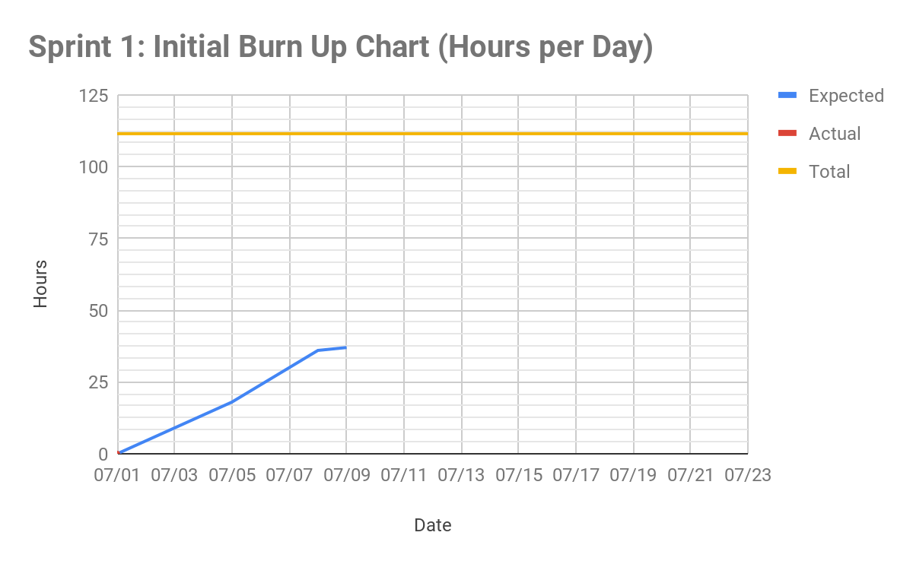.

**Initial Scrum Board**

*Also known as a task board, the scrum board is a physical board and labeled as such with sprint number and project name and located in the lab. This board has four columns, titled user stories, tasks not started, tasks in progress, and tasks completed. Index cards or post-it notes representing the user stories and the tasks for this sprint should be placed in the user stories, tasks not started, and tasks in progress columns. Tasks associated with a user story should be placed in the same row as the user story.*

Our scrum board is done virtually, on Trello: <https://trello.com/b/YSJKqsrP/sprint-1>

**Scrum Times**

*List at least the three days and times during the week when your team will meet and conduct Scrum meetings. Also, indicate which of these meetings will have the TA/tutor  visit as arranged with the TA/tutor. It is expected the TA/tutor will visit during the Scrum meeting during your lab time.*

Monday: 1:30 - 2:00 pm [TA present]

Wednesday: 1:30 - 2:00 pm [TA present]

Friday: 11:30 - 12:00 pm